**MINI PROJECT**

CE-02-23(PO)

**Assessing the Applicability of AI/ML Techniques for River Morphological Change Detection**

Submitted By:

Aryan Sheel(2022UCS0082)

Devesh Sharma(2022UCS0090)

Ayush Sinha(2022UCS0086)

Shubham Kumar Maurya(2022UCS0111)

**INTRODUCTION**

Rivers are dynamic natural systems that constantly undergo morphological changes over time, influenced by various environmental factors. Understanding and monitoring these changes is crucial for effective river management and ecosystem preservation. In the past, manual methods were primarily used to track river paths and assess morphological alterations. However, with the advent of Artificial Intelligence (AI) and Machine Learning (ML) techniques, there has been a significant advancement in river morphological change detection.

This study explores the application of AI and ML techniques in tracking and analyzing different river paths over a span of 30 years. By examining dependencies within river systems and observing morphological changes using features such as corridors, centerlines, and sandbars, we can gain deeper insights into the dynamic behavior of river. Additionally, ML models offer the potential to predict future river paths based on historical data, providing valuable information for proactive management strategies.

**OBJECTIVE**

Understanding long-term changes in river morphology is crucial for environmental management and infrastructure planning. This study focuses on the Penna River in Andhra Pradesh, spanning three decades from 1991 to 2020.

Our research aims to track the different paths of the Penna River over the designated 30-year period, elucidating the dependencies of its course and observing morphological changes using features such as corridors, center lines, and sandbars. Through meticulous data collection and manual processing, we intend to compile a comprehensive dataset detailing the river's course and its surrounding corridor, facilitating further computational analysis.

Originating from Karnataka's Nandi Hills and flowing to the Bay of Bengal, the Penna River offers diverse landscapes for analysis. We aim to track its paths, study dependencies, and observe morphological changes using features like corridors and sandbars.

By combining data collection with AI and ML techniques, we intend to develop a computational model for predicting future river paths. This research contributes to understanding river dynamics and informs sustainable management practices for river ecosystems and infrastructure development.

**DATA COLLECTION APPROACH**

* We collected Landsat satellite images in different bands.
* Then with QGIS we traced the center-line of the river, river corridor and sand bars.
* With traced data we calculated the sinuosity index, area of the river corridor and area of erosion and deposition of the two consecutive years.
* Further, we aim to use the generated data to train AI models to predict these above parameters.

**METHODOLOGY**

* We first collected satellite images in different bands from USGS.
* The satellite used to derive the images are LANDSAT 5, 7 and 8.
* Timeline of used satellite: Landsat 5 1990-1999, Landsat 7 2000-2013, Landsat 8 2014-2020.
* The bands of images are B1, B2, B3, B4, B5, B6 and B7.
* We then imported all these .tif images in the QGIS software.
* Then we carefully traced the mentioned parameters in the images.
* These traced images are then exported in different shape file.
* Using these shape files we calculated the erosion, deposition, etc.

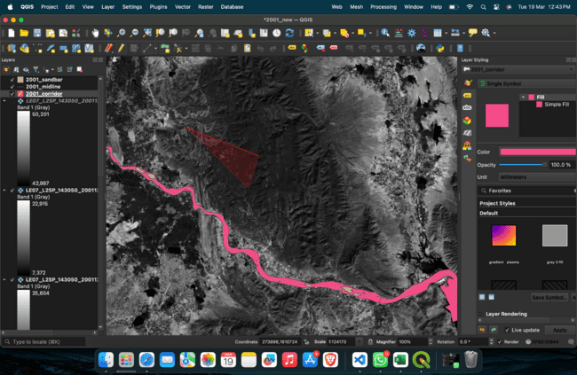

**Fig. 1.** Digitized Images in QGIS Software

**STUDY AREA**

* Penna River is flowing through Karnataka and Andhra Pradesh.
* It is 597 kilometers (371 mi) long, with a drainage basin covering 55,213 km2, 6,937 km2 in

Karnataka and 48,276 km2 in Andhra Pradesh.

* For our study we choose the section between Kamalapuram to Somasila Dam & Reservoir.
* The length of the river is about 55 km long.
* The average discharge of Penna river is around 46000 cubic feet per second (cfs), while the minimum discharge is around 270 cfs.
* There are several small and large hydraulic structures on Penna river.

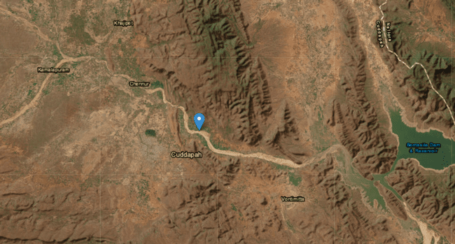

**Fig.2. The Penna river reach between Kamalapuram to Somasila Dam ©earthexplorer.usgs.gov**

**BUT WHY PENNA RIVER**

* **Diverse Geographical Features:** It flows through varied landscapes, offering insights into how different terrains influence river morphology.
* **Human Impact:** Significant human activities along its course provide a relevant case study for understanding anthropogenic influences on river morphology.
* **In Channel Interventions:**Unique features such as channel dynamics, sedimentation patterns, cascading hydraulic structure and anthropogenic influences make it an ideal region for morphological studies.

**RESULTS**

* River corridor area was more comparable to recent years.

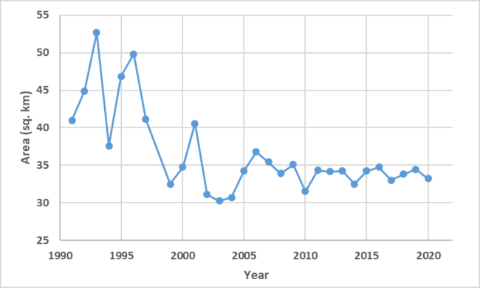

**Fig 3. Variation of Penna River Corridor area over years**

* Erosion and deposition portion from 2017 to 2018.

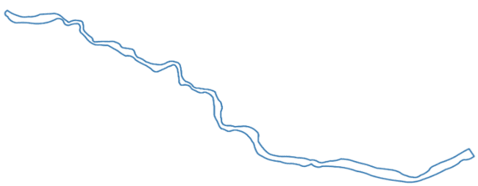

**Fig 4. River corridor boundary of 2017**

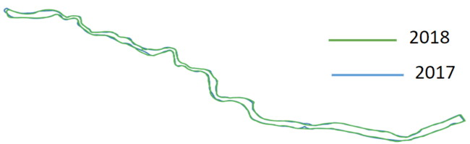

**Fig 5. Superposition of Penna river bed of 2018 over 2017**

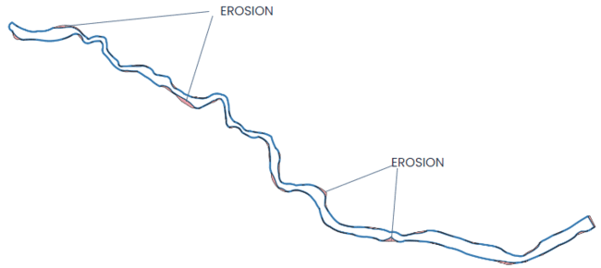

**Fig 6. Erosion of river bed 2017-2018**

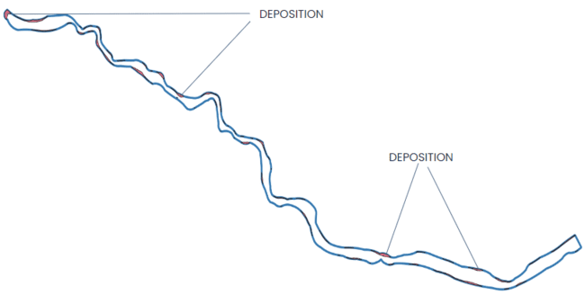

**Fig 7. Deposition of river bed 2017-2018**

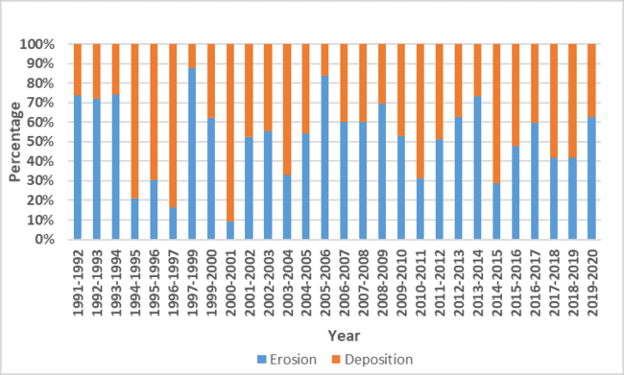

**Fig 8. Distribution of Erosion and Deposition over years**

* Penna river curved length variation and Sinuosity index.

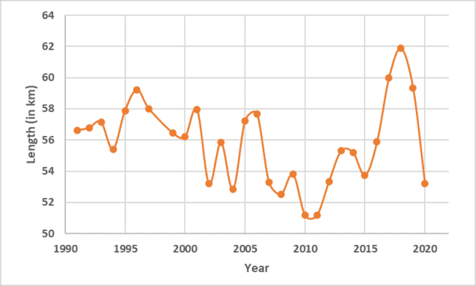

**Fig 9. Variation of curved length of river over years**

**SINUOSITY INDEX**

**S.I. = C.L./V.L.**

SI: Sinuosity Index

CL: Curved Length

VL: Valley Length

(V.L.= 46.171 km)

For rivers, the conventional classes of sinuosity, SI, are:

* SI <1.05: almost straight
* 1.05 ≤ SI <1.25: winding
* 1.25 ≤ SI <1.50: twisty
* 1.50 ≤ SI: meandering

Observation from Curved length and Sinuosity Plot over years.

1. Variation has been increasing in the Sinuosity index after 2010.
2. It can be concluded that increase in meandering of river is increases sinuosity.

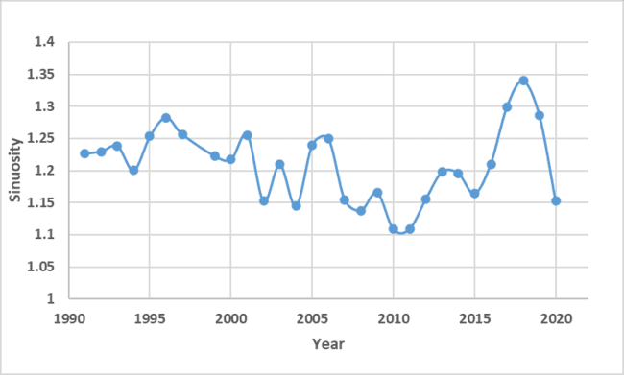

**Fig 10. Variation of Sinuosity Index of river over years**

**MODEL SELECTION AND TRAINING APPROACH:**

After successfully computing various morphological features spanning three decades, our next step is to employ machine learning (ML) techniques for predicting selected morphological attributes in the future. To achieve this, we've incorporated three distinct ML algorithms into our predictive model. This approach allows us to use the pre-computed data as training inputs, enabling us to forecast forthcoming morphological features with greater accuracy and reliability.

For training of the models we divided the dataset into two parts: training and testing in a ratio of 5:1. For the training we incorporated three ML algorithms Linear regression, SARIMA and ARIMA.

**Linear Regression:Analysis of Linear Regression Model Performance**

Linear regression is like drawing a straight line through data points on a graph. It helps us understand the relationship between two variables by fitting a line that best represents the data.

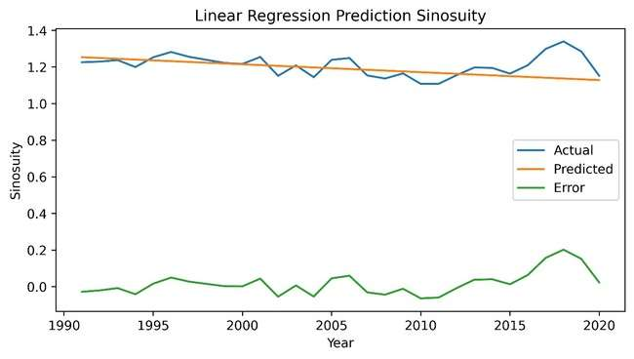

Fig 11.Prediction,Actual Data,Absolute Error plotted against Year.

We employed a linear regression model to analyze the relationship between sinuosity and the year. Through visual inspection of the actual versus predicted values graph, we observed fluctuations in the errors across the years spanning from 1990 to 2020.To quantify the overall predictive performance of our model, we calculated the root mean square error (RMSE). The resulting RMSE value was found to be 0.06633718.

**SARIMA (Seasonal AutoRegressive Integrated Moving Average):**

SARIMA is an extension of ARIMA that takes into account seasonal patterns in time-series data. It considers not only the overall trend but also recurring patterns that occur at regular intervals (seasonality).

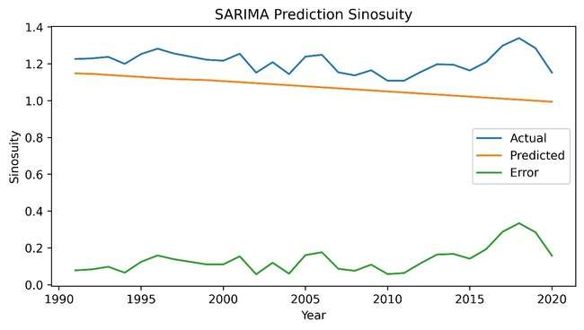

Fig 12.Prediction,Actual Data,Absolute Error plotted against Year.

Utilizing a SARIMA model, we examined sinuosity trends over time. The RMSE, calculated as 0.1525133, indicates minor deviations between actual and predicted values from 1990 to 2020.

**ARIMA (AutoRegressive Integrated Moving Average):**

ARIMA is a forecasting technique that takes into account the series of data points over time, including trends and seasonal patterns. It uses past values to predict future ones

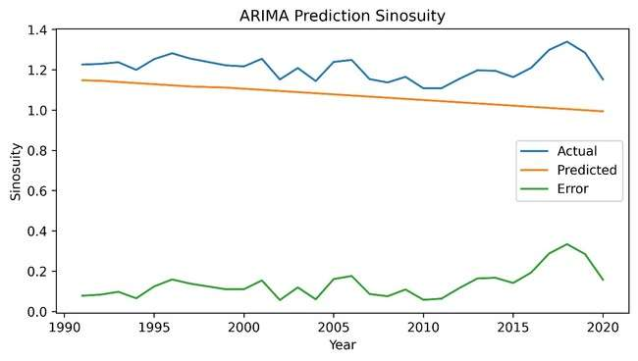

Fig 13.Prediction,Actual Data,Absolute Error plotted against Year.

ARIMA model provided valuable insights into the relationship between sinuosity and year. The RMS of 0.1525133 serves as a measure of the model's predictive accuracy, guiding us in understanding the extent of deviations between predicted and actual sinuosity values.

**RESULTS**

* By observing the above graphs and the errors we can conclude that the errors which we are getting are very high with respect to the values.
* The model is overfitting the training data and is not able to generalize well to new data.
* The model performed well on the seen data but failed to predict accurately on the unseen data.

**A THEORETICAL APPROACH FOR BETTER PREDICTION TASK**

Upon analyzing the reasons for shortcoming of our ML models we can adapt a different approach for Building ML models and training data with high efficiency.

We can use different remote sensing techniques to extract river body from the satellite images which can be used to calculate more reliable data.

Also using remote sensing techniques further helps us in significantly increasing our dataset and hence increasing the model accuracy.

Further using more complex models like neural networks for model training can significantly improve the prediction task.

**REMOTE SENSING TECHNIQUES FOR RIVER CHANNEL DETECTION**

**IMAGE SEGMENTATION AND EDGE DETECTION**

Image segmentation and edge detection algorithms follow the process of manual digitization more closely by dividing an image into different regions where sharp intensity alterations occur. The “alternative connective approach”, one of two major image segmentation and edge detection algorithms, is used in deltaic research where it seeks to grow homogeneous regions by merging pixels or sub-regions on the basis of some similarity criterion.

**BAND RATIOING**

This method exploits the near-infrared (NIR) and short-wave infrared (SWIR) bands whose wavelengths are absorbed by water, resulting in surface water rendered as black color in the processed image. A combination of these spectral bands is used to reduce the effect of suspended sediment near shorelines and accentuate higher reflectance characteristics from soil and healthy vegetation, providing a context for the land/water interface.

A commonly used index is NDWI (normalized difference water index).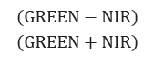

NDWI=

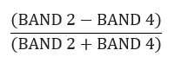

For landsat 7 NDWI=

**SUPERVISED CLASSIFICATION**

In supervised classification, the analyst selects sample pixels in an image that are representative of land cover classes, and then directs the image processing software to use these end-member pixels (training pixels) as references for the classification of all other pixels in the image (determination of maximum likelihood of image pixels of a land use class based on training data).

Supervised classification can be beneficial for us as in our case pixels of water and surrounding areas are merely differentiable. Using training pixels may increase the accuracy of pixel detection as compared to other classification techniques that work on predefined classes.

**USE OF NEURAL NETWORK FOR PREDICTION TASK**

**DATA COLLECTION AND PREPARATION**

We will be using our pre computed data of 3 decades for preparation of the network**.**

Split the data into training, validation, and test sets. Typically, you might allocate around 70-80% of the data for training, 10-15% for validation.

**MODEL SELECTION**

* We will choose a neural network architecture suitable for our prediction task. For predicting river morphology changes, we will start with a simple lightweight neural network or consider more advanced architectures like recurrent neural networks (RNNs) or long short-term memory (LSTM) networks, which are well-suited for sequential data.
* Define the number of layers, neurons per layer, and activation functions for your neural network. Experiment with different configurations to find the one that best fits our data.

**MODEL TRAINING**

* Initialize the neural network model with random weights and biases.
* Train the model using the training data. During training, the model learns to map input features (e.g., historical river data) to output predictions (e.g., future morphology changes).
* Use an optimization algorithm such as Adam to minimize the loss function, which measures the difference between the predicted values and the actual values in the training data.
* Monitor the model's performance on the validation set to prevent overfitting. If the model performs well on the training data but poorly on the validation data, it may be overfitting and not generalizing well to new data. Adjust the model architecture or introduce regularization techniques (e.g., dropout) to mitigate overfitting.

**CONCLUSION**

* The data does not have a clear trend or seasonality.
* Some errors during manual digitization of river corridors due to very low distinction between the river channel and surrounding land led to some unknown trends in the data which reduced model efficiency.
* The limited dataset posed significant challenges during model training, resulting in poor performance during prediction tasks.
* As described in our theoretical approach, using remote sensing techniques for river body classification can help us in eliminating the above two problems.
* The model is not complex enough to capture the underlying pattern in the data.
* As described in our theoretical approach, using a complex model like a neural network can capture the underlying patterns more efficiently and increase the accuracy of our prediction task.

**REFERENCES**

1. Deng B, Xiong K, Huang Z, Jiang C, Liu J, Luo W, Xiang Y. Monitoring and Predicting Channel Morphology of the Tongtian River, Headwater of the Yangtze River Using Landsat Images and Lightweight Neural Network. Remote Sensing. 2022; 14(13):3107.

2.Munasinghe, D., Cohen, S., & Gadiraju, K. (2021). A Review of Satellite Remote Sensing Techniques of River Delta Morphology Change. *Remote Sensing in Earth Systems Sciences*, *4*(1), 44-75.

3.Kumar, L., Afzal, M. S., & Afzal, M. M. (2020). Mapping shoreline change using machine learning: a case study from the eastern Indian coast. *Acta Geophysica*, *68*(4), 1127-1143.